AGRO TOURISM AND RURAL DEVELOPMENT IN SRI LANKA
With Special Reference to Nuwara Eliya District

Dr. S.M.P Senanayke and Rev. Dr. Wijitapure Wimalaratana

Abstract
Sri Lanka is a tropical island in the Indian Ocean. It has been one of the major tourist attractions since long. Tourism is booming in the island once again at the end of a long civil war though its benefits are still confined to a few locations under a few players in the industry. The island is rich in rural tourism resources with a great appealing to a visitor. Such resources range from fauna and flora, aesthetic landscapes, streams and waterfalls, irrigation tanks and canal systems, beautiful beaches, mouth watering tropical fruits and vegetables, historical monuments, music, dance, festivities, authentic foods, beverages, traditional agriculture, local costume, indigenous medicine and healing methods, traditional arts and sports. The island caries an overwhelming majority of rural population and this will continue well into the middle of the century. Interestingly rural agricultural characteristics have been preserved to a great extent in many parts of the country as those areas have not yet received that much of urban influences. Similarly economic problems as well as development potentials still remain in agricultural areas side by side. Only a small fraction of the vast rural agro tourism resource base is being utilized by the industry now with little or no benefits to rural people. Dedicated research work on agro tourism will promote that sector with the participation of policy makers, rural communities and private investors on a sustainable manner while trickling down a reasonable fraction of the benefits to the rural people. This would diversify their agricultural livelihoods and improve their incomes and living standards. This paper examines agro tourism and rural development of Sri Lanka with special reference to Nuwara Eliya District, a popular rural tourism destination in Sri Lanka.
Key Words: agro tourism, foods, plantation, fruits, vegetable, tourists, rural sector.

Introduction
Individual mobility from place to place for different purposes is the norm of the modern society. Inquisitiveness and curiosity are always involved with mobility to unfrequented locations. It is a well known fact that the globalization waves have further intensified this trend. The ‘traveller’ was the name given to the tourist in olden days when the modes of travelling were primitive and the risk involved with travel was extremely high. Firsthand accounts made by early travellers are referred ‘‘travellers’ records’ in modern days. Travelling triggered either by recreational or leisure motive is generally referred as tourism. In the recent past travelling opportunities as well as motives have changed and intensified overtime along with the technological advancement, rising productivity and attitudinal changes. Travelling motives have shifted from traditional ‘recreation or leisure’ to such areas as education, sports, business, medical and adventure. New products such as ‘agro tourism’, ‘adventure tourism’, ‘sport tourism’ and ‘sustainable tourism’ have emerged reflecting the changes in this sector.
Many terms have been used to convey the meaning of agro-tourism. These include agricultural tourism, agri-tourism, farm tourism, farm vacation tourism, wine tourism, and agri- entertainment. Generally, these terms refer to small-scale farm enterprises and community events that showcase the activities and produce of rural families and the agricultural heritage of farming regions to travellers. Agro-tourism provides “rural experiences” to travellers with the goal of generating revenues for farmers and surrounding communities. These experiences typically include a wide range of attractions and activities that take place in agricultural areas. Important ingredients of agro-tourism’s “rural experiences” include open spaces, low levels of urban or industrial development, and opportunities for visitors to directly experience agricultural, pastoral, and natural environments.
Agriculture in its modern sense is divided into two as urban agriculture and rural agriculture. Agro-tourism, however, is the launch of activities aiming at the economic and social development of rural and country regions in general. The location of agro tourism broadly covers land areas not covered by cities, towns, urban areas and suburbs. Such locations are called country, countryside and hinterlands invariably. Agro tourism combines agricultural or rural settings and products within a tourism experience. The scope of agriculture encompasses through farming for human foods, beverages, fodder and fibre; livestock products; hunting, fishing, and forestry. When it comes to agro tourism, the scope of the subject expands into agro based industries, modern and traditional services in agricultural areas and also culture, believes, and value systems in the same areas. Some general features of such geographical locations are remoteness, small scale, low density of human settlements and low degree of specialization.
In the beginning, agro-tourism (often found as ecotourism or rural tourism) started to diversify rural activities and agricultural practices. Nowadays, it acquires a highly acceptable environmental protection concept. Offering market-linked long-term solutions, ecotourism provides effective economic incentives for conserving and enhancing bio-cultural diversity and helps protect the natural and cultural heritage. One definition of agritourism was given by Weaver and Fennell (1997): “Rural enterprises which incorporate both a working farm environment and a commercial tourism component”.
While ‘nature-based tourism’ is simply described as travel to natural places, ecotourism is a type of nature-based tourism that benefits local communities and destinations environmentally, culturally and economically. It works by promoting small-scale, local production and touristic activities. Agritourism functions as a mechanism against urbanization, spreading the message of environmental protection.
The last three decades have seen a significant increase in the number of farm families diversifying their farm production. Moreover, agritourism is intrinsically connected to sustainable development, hence environmental protection. It offers relevant information and advice on how travellers can minimize the impact on the ecosystem as well as how they can contribute to the protection of fragile ecosystems. This target can be achieved by promoting and supporting: (a) Moderate and small-scale tourist services, (b) Local agricultural production, (c) The manufacture and trade of traditional products, and (d) Local culture and natural wealth
Agro-tourism, is the process of attracting visitors and travellers to agricultural areas, generally for educational and recreational purposes (Lamb, 2008; Veeck et al. 2006). Many farmers all over the world especially those who have small-scale, family-owned farms have understood the necessity to supplement their agricultural business model and find new ways of generating income. Agro-tourism can contribute to the overall income, cash flow and profitability of a farm by providing alternative income via farm products, and farming activities (Colton and Bissix, 2005; Huybers, 2007; Keith et al. 2003; Sharply, 2002).
Further, agro-tourism can also be explained as a holiday concept of visiting an agribusiness operation for the purpose of enjoyment, education or involvement in the activities of the operation. . In developed countries this includes you-pick operations, corn mazes, hay rides, pumpkin patches, dairy tours, and more (Adam, 2004). Therefore, agro-tourism may be any form of farm-based tourism operation that provides economic benefit to the farm owner(s) and provides on-farm entertainment, activity, or product for the visitor. Normally, agro-tourism is small-scale, low-impact and in most cases, it is mainly focused on education (Wicks, and Merrett, 2003; Wall, 2006).In agro-tourism a native or local farmer offers tours to their agriculture farm to allow visitors to view them growing, harvesting, and processing locally grown crops such as maize, sorghum or any produce the person would not come across in their areas. Often the farmers would provide farm-stay opportunities including educational programs and recreational activities (Nilsson, 2002; Weaver and Fennell, 1997). Important advantages of agro-tourism are; 1) the ability to bring the main primary industry (agriculture) and the major service sector (tourism) together, by creating win-win situation for both sectors,2) enhancing the possibility of the enlargement of the tourism sector and 3) the ability to absorb the expanding tourism sector (Singh, 2007).
Many agro-tourism activities need only a small team of farm labours in order to be successful. For example, farm tours, farm stay with bed and breakfast, tractor or bullock cart rides, picking of grapes, mangoes, and other horticulture items, farm zoos, and many other activities may be operated with little additional expenditure on labour (Agro-tourism Development Organization in India, 2008; Taware, 2009).

In its purest sense, agro-tourism refers to travel which combines rural settings with products of agricultural operations – all within a tourism experience that is paid for by visitors. Examples of these experiences include: visiting farmers’ markets to purchase farm fresh products, taking part in orchard and floral garden tours, using farm bed and breakfast accommodation, and participating in harvest festivals. The full range of agro-tourism product and service development options can be categorized within three broad themes – fixed attractions, events, and services. All require careful management and supporting development resources.

Scope of Agro-tourism Concept

Agro-tourism as a concept covers rural /natural environments; agricultural products, processing and packaging; agro based services; rural community and their culture/belief system; tourism products. Each and every component in this list is interdependent even though they are compartmentalized for the sake of discussion. In general, human activities, either evolved within the location itself or externally introduced, are mixed with the natural endowments in creation and supply of tourism products.

Fixed tourist attractions in a location are current or potential generators of tourism. They range from historic farms whose primary purpose is to attract visitors, to existing agricultural buildings and natural features that are appealing sites for agro-tourism activities. The five primary types of fixed attractions are historic farms, living farms, museums, food processing facilities, and natural features such as ponds and wooded areas.

Based on an agricultural or seasonal theme, events are often highly appealing products that farm operators can organize. They differ from fixed attractions because of their limited period of operation (e.g. a single day to a few weeks). Different types of events include conferences/ conventions, agricultural fairs, historic events, and festivals.

Tourists typically require a range of services to “fill out” their agro-tourism experiences over time and space. Prudent initiatives are required to maintain the sustainability of the industry in a particular location. The component of the ‘community participation is essential .rather than they are kept as simple onlookers. Tourist services are traditionally divided into four primary categories as;

- Accommodations such as bed and breakfasts (vacation farms). Bed and Breakfast (B&B) is specially confined to small lodging establishments which provide overnight accommodation without lunch and dinners. Sometimes agreement under B&B extends to self catering facilities. This practice agrees well with small farmlands, especially in developing countries. Isolated cottages in or close to farmlands would be able to use for the purpose. A family/group/couple individual can stay in a farm feeding animals, watching environment, picking and cooking of farm products.

- Tours associated with production or processing facilities (e.g. food processing operations), or scenic environments (e.g. botanical gardens, herbal and floricultural, plantation heritage sites). These tours may be delivered by outside agencies (e.g. school teachers) or on-farm staff.

- Retailing services selling local produce and farm-processed products (e.g. jams, spices; “u-pick” fields and orchards; gifts, crafts and baked goods).

- Leisure/recreation activities centred on events or attractions such as indigenous cuisine, wellness pursuits, biking, hiking etc.

The IICA publication entitled “Cultivating Agritourism, A Guide for Establishing Agritourism Resource Centre in the Caribbean” (undated) lists following benefits from agritourism for farmers, their communities and tourism operators.
Table1. Agro Tourism Benefits
Benefits for Farmers | Benefits for Communities | Benefits for Tourism Operators
For farmers, agritourism is a potential way of:  • expanding farm operations;  • using farm based products in new and innovative ways;  • improving farm revenue streams;  • developing new consumer market niches;  • increasing awareness of local agricultural products;  • increasing appreciation of the importance of maintaining agricultural land;  • channeling additional on-farm revenues directly to family members;  • improving farm living conditions, working areas and farm recreation opportunities;  • developing managerial skill and entrepreneurial spirit; and  • increasing the long term sustainability for farm businesses | From a community perspective, agritourism can be a vehicle for:  • generating additional revenue for local businesses and services from tourists;  • upgrading / revitalizing community facilities for residents and visitors;  • increasing protection of rural landscapes and natural environments for tourists and residents;  • helping preserve and revitalize local traditions, art and craft;  • promoting inter-regional, inter-cultural communication and understanding;  • increasing awareness of agricultural issues and values among the public;  • promoting the on-going use of local agricultural products and services;  • helping to diversify and strengthen the rural economy via job and income creation; and  • providing a more energetic business environment for attracting other businesses and small industries. | From a tourism industry viewpoint, agritourism can be a means of:  • diversifying the mix of tourism products and services available to visitors;  • increasing tourism flows into attractive rural regions;  • increasing season length during traditionally off-peak business periods;  • Uniquely positioning rural regions in key tourism markets; and  • bringing more foreign currency to local businesses

Agriculture and Rural Sector of Sri Lanka
Sri Lanka, a tropical island in South Asia, lies above the equator between 5° 55'N and 9° 55' N and between the Eastern longitudes 79° 42' and 81° 52'. The total land area of the island is 65,610 sq km and the length of the coast line is 1340 km. Nearly 23.2 percent of the land mass of the island belongs to wet zone where rainfall widely spreads throughout the year guaranteeing low temperature and ever greenly environment. This part of the island has been home for the major plantation crops and spices for centuries. The intermediate zone carries 13.3landmass while the balance 63.5 belongs to the dry zone. The widespread irrigation facilities, monsoon rains, and fertile lands have created a rich environment for the domestic agriculture in these areas. Agricultural and environmental diversity of the country is further intensified by the topographical differences. The elevation of the island gradually goes up from the costal belt through the central hilly areas while reducing the temperature level inversely.

Agriculture of Sri Lanka consists of two major sectors as domestic (traditional) agriculture and plantation (modern) agriculture. The former, consisting of food production and related activities, has evolved within the country itself for more than 2000 years while the latter, consisting of tea and rubber cultivations, was introduced to the country in the nineteenth and twentieth century’s by the British colonial administration. The coconut cultivation, the third component of the modern (plantation) agricultural sector had been in the domestic agriculture for centuries, mainly in the food sector in a small scale before being incorporated into the plantation agriculture as large and medium scale cultivation units for export purposes during the colonial administration. However, the traditional small coconut gardens remained intact side by side with the plantation sector. All the aforementioned sectors of Sri Lankan agriculture have more or less development potentials for promoting the tourism sector side by side of existing activities.
Agriculture of Sri Lanka, excepting small scale rubber and tobacco sub sectors, consists of food and beverage items. However, the domestic agriculture plays an important role in the food production for the local market and export in small quantities. Tea production, as a beverage crop in the modern sector, mainly targets the global market. It is safe to say that there is not that much difference between the food production and agriculture in the country,
The rural sector of Sri Lanka is dominated by the food production consisting of rice in irrigated and marshy lands and other food stuffs in higher lands. In the wet zone, high lands mainly consist of small mixed gardens where coconut, fruits and vegetables are mainly cultivated and on some occasions a few cattle and birds are also kept. Shifting cultivation practice is still visible in some dry parts in addition to mixed crops gardens in those areas. Two main types of vegetables are grown in Sri Lanka based on agro-ecological adaptability. European varieties of vegetables such as leeks, carrot, cabbages, and beetroots are cultivated in high elevated areas where temperature is low while more tropical varieties such as pumpkin, bitter gourd, snake gourd, and cucumber are cultivated in low elevated areas where temperature is high. Such fruits as banana, papaya, mango, pineapple, and jackfruit are widely cultivated in mixed gardens in many parts of the country although there are some regional variations. Poultry faming and cattle rearing, inland water and sea fishing are common practices in the rural sector of the country.
Sri Lanka has maintained a rural sector biased dwelling pattern and human settlements with some modern urban facilities required for the modern life style of the inbound tourist. Sri Lanka will have higher percentage of rural population even in the middle of this century. Sri Lanka is also one of the countries with highest population density in the world and the situation will further be aggravated in the future even though population growth is slowing down. The ultimate outcome of this trend would be the gradually declining farmland size in the countryside thus requiring alternative income sources other than cultivation. The agro tourism would be an ideal solution for this impending future challenge of rural Sri Lanka. The rural sector based tourist friendly resources other than agriculture would be added advantages in this endeavor. Such resources as rich culture and cultural diversity, smiling faces, visitor friendly behavioral pattern, and mouth watering local culinary would essentially be helpful in promoting agro tourism in rural Sri Lanka.
Table 2
Basic Information of Population in Sri Lanka
Year | Mid Year Population (Thousands) | Population Growth Rate | percentage of Rural Population | percentage of Urban Population | Population Density per sq.km
1950 | 7544 | 3.3 | 84.7 | 15.3 | 126
1960 | 9896 | 2.8 | 83.6 | 16.4 | 153
1970 | 12514 | 2.1 | 80.5 | 19.5 | 191
1980 | 14747 | 1.9 | 81.2 | 18.8 | 230
1990 | 17105 | 1 | 82.2 | 17.2 | 271
2000 | 19102 | 1.3 | 84.3 | 15.7 | 305
2009 | 20450 | 1.1 | 84.7 | 14.1 | 326
2030 | 22194 | 0.05 | 78.6 | 21.4 | 338
2050 | 21705 | -0.28 | 66 | 34 | 331
Sources: Sri Lanka Census and Statistics, Central Bank of Sri Lanka, UN Population Division

Agriculture sector’s contribution as a percentage to the GDP has drastically reduced since the political independence of the island while it still provides livelihoods for a large percentage of the labor force of the country. Agriculture contributed nearly 12 percent to the GDP in 2010 while it provided occupation for nearly 33 percent of the labor force. Average income of those who are engaged in agriculture is low compared to those earned by industry and service sector workers economy, so that rising of income in agriculture sector through alternative income generating strategies would be essential if the living standards of rural population are to be improved and rural poverty is to be reduced.
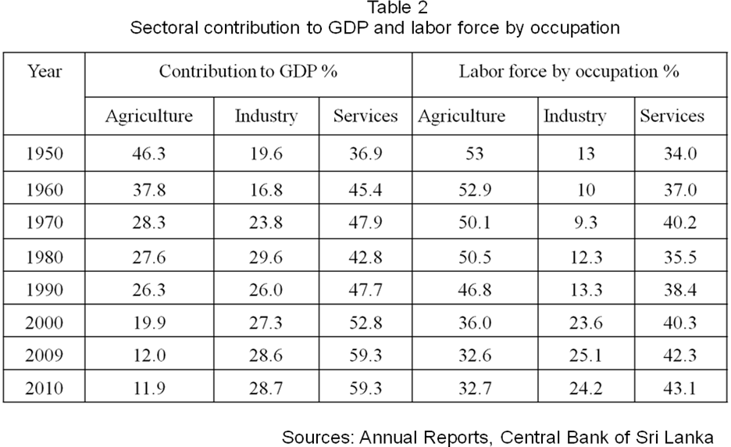
Even though population of the country is divided into three categories as urban, rural, and estate for the convenience of administration and also to reflect historical division, both estate and rural sectors come under the same banner of agriculture. Agro tourism products and development strategies are more or less the same in these locations.
As household income and expenditure surveys show (table 3) agriculture sector representing both the rural and estate sectors record poor performances in many areas compared to the urban sector of the economy. The most striking feature of these two sectors is comparatively high poverty level. There seem to be certain limitations to reduce poverty level further sticking only to traditionally assigned activities of those sectors. Alternative strategies should be explored and exploited for this purpose. There are huge untapped potentials in both sectors to improve the living standards of communities living in those sectors and one of them is tourism potential and related activities. Among many others, seasonal as well as fulltime agricultural activities, seasonal and geographical variations of products, flavor and appearance, rituals and ceremonies involved with agriculture, unmatched natural environment with its fauna and flora, open-minded and friendly people, absolutely peaceful and secured living environment, special rural culinary, can be made use of to provide the basis for agri-tourism development of the country.

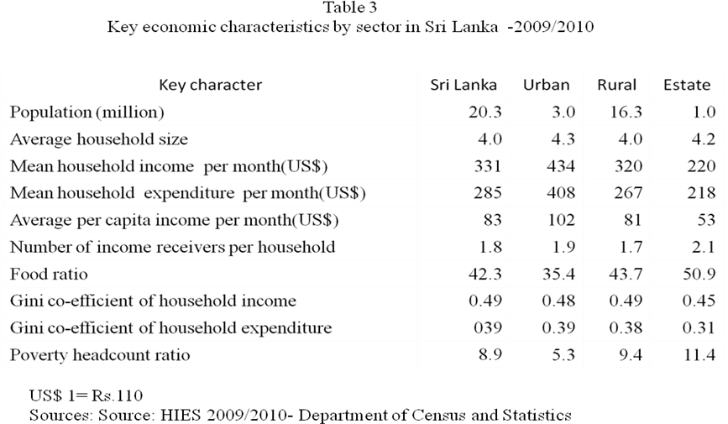
Tourist Arrival to Sri Lanka
Sri Lanka is a tropical island with an exceptional biodiversity and rich cultural heritage with high potential to draw the attention of the tourist who expect for a vast experience within a short period of time. Sri Lanka has inherited multitudes of tourism resources within a small geographical location. Popular tourist destinations are located in close proximity, so that the distance and travel time between tourist attractions are negligible. For example the travel time through lush rural agricultural hinterlands between the world class beaches of tourist facilities in Southern Sri Lankan Galle to the cool hilly Nuwara Eliya district is about six hours by road. Similarly, a journey from the commercial city of Colombo to ancient kingdoms of the North Central province through rural Sri Lanka again would take nearly six hours.
Tourism has become a fast growing sector of the economy of Sri Lanka after the thirty years old civil war of the country. Local and foreign investments are constantly flowing into the sector to be the leaders of many tourism products although agro tourism has not received that much interest. Tourist arrival is expected to rise exponentially in the near future as the country is currently enjoying a new era of political stability and security which is well above the many popular tourist destinations in the world. Similarly, old tourist attractions in war ravaged regions have been added to the tourism product basket. Interestingly the civil war affected Northern and Eastern provinces of the island have plenty of untapped agro based tourism potential.
Figure 1: Tourist arrival to Sri Lanka
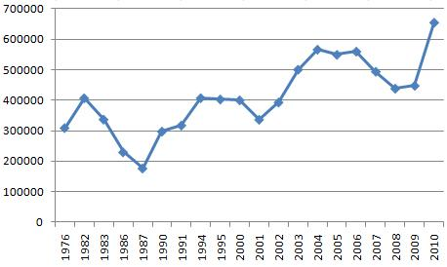
Sources: Sri Lanka Tourism Development Authority and the Central Bank of Sri Lanka
Tourism arrival has reached to a new record level in the recent past. Number of tourists arrived to the island has reached to a record 0.75 million by the end of 2011. It is estimated that the number of tourist arrival will reach to 2.5 million by 2016, if the tourism growth momentum continues during the next five year period of time.
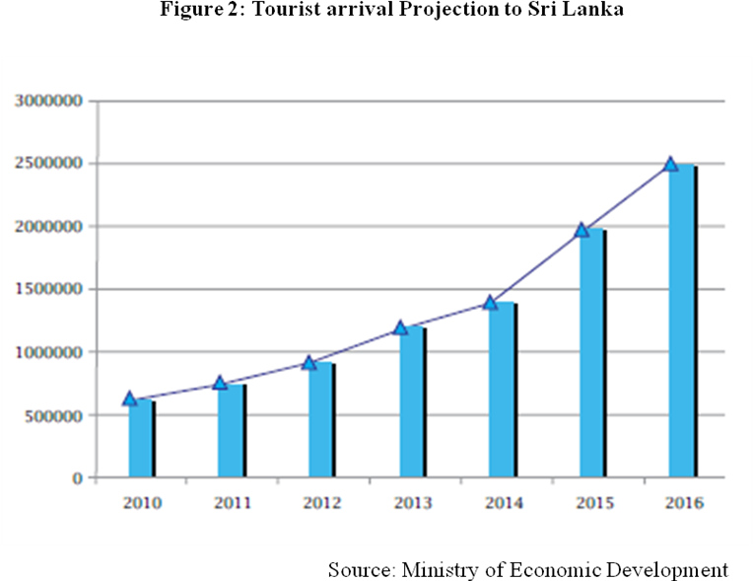
Income as well as employment generated from the tourism sector will go up along with the growth of tourist arrival in the future. If a considerable fraction of tourists are directed to the agricultural sector through prudent innovative tourism products with the participation of the community, income and employment generation ability of this sector can be increased while improving the living standards of the sector.
Tourism season in Sri Lanka coincides with its mild winter period during the November-January period and the climatic condition of the country is very much close to the summer in temperate climate although humidity is little higher. The season comes after the inter monsoon and during a part of the north eastern monsoon and difficult to distinguish dry and wet parts of the country during season. The entire country is green and fruits and vegetables are also in plenty almost everywhere. The maha (great) cultivation season falls during the same period and all rice fields, gardens and also shifting cultivations are in full swing. Animal and bird breeding seasons also fall during this period of time, so that many creatures are easily visible in the countryside. This is also the season for migrant birds and they are visible in many parts of the island even though there are special high attraction locations. Fish harvest is also high during the season and different types of fish varieties are available from the market. .
Still sufficient number of tourists does not come to the agriculture sector and this is very much true with the domestic agriculture. However, some of their products such as vegetable, fruits, and fish are purchased buy the tourist service providers mostly through middlemen, so that income is not trickle down to the farmer. Introduction of the agro based tourism products with the participation of the local community is an essential strategy of the hour in the wake of rising tourism arrivals to the country.

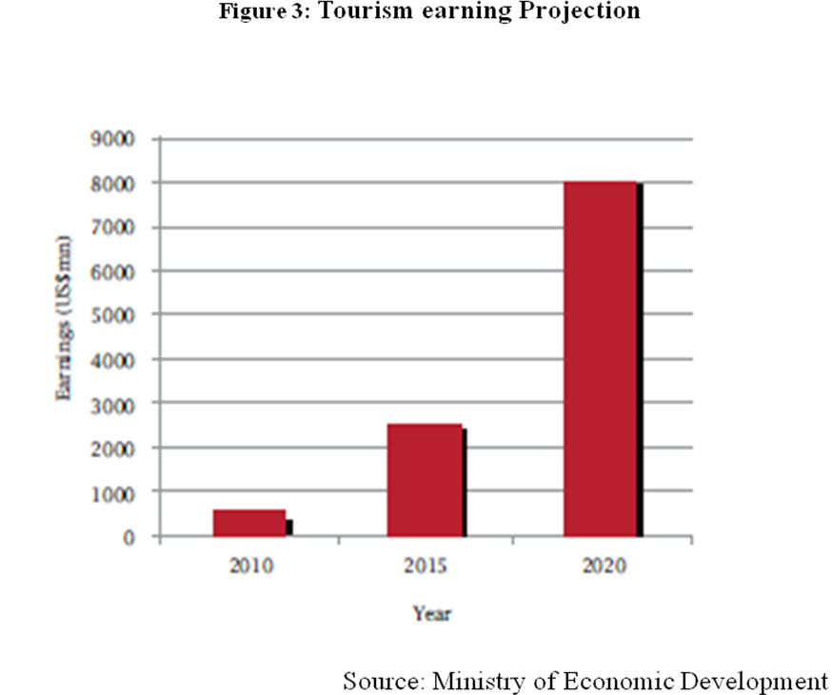
Agro- tourism in Sri Lanka
There are a huge potential for agro-tourism sector of Sri Lanka although it is still in its’ initial stages. Only a few agro-tourism destinations are operating at present with general facilities and services. The remarkable increase in the interest surrounding the concept of agro-tourism of other countries is influencing the development of agro-tourism in Sri Lanka. Sri Lanka is a suitable destination for agro-tourism. It has diverse agro-climatic conditions suitable for growing different types of crops, fruits, vegetables and trees. Sri Lanka’s complex paddy cultivation systems (developed over the course of 2500 years), huge and very old irrigation tanks, many tea and rubber plantations, milking cattle on dairy farms, having a go at plucking tea leaves using the traditional ‘bag-on-the-back' method, rubber tapping under expert guidance, or even working in many scenic paddy fields ( ploughing using bullocks, work on paddy nurseries, transplanting seedlings in muddy fields) of Sri Lanka are just some examples of its diverse agricultural developments.(Advisory Panel on Community Based Sustainable Tourism in Sri Lanka, 2008).

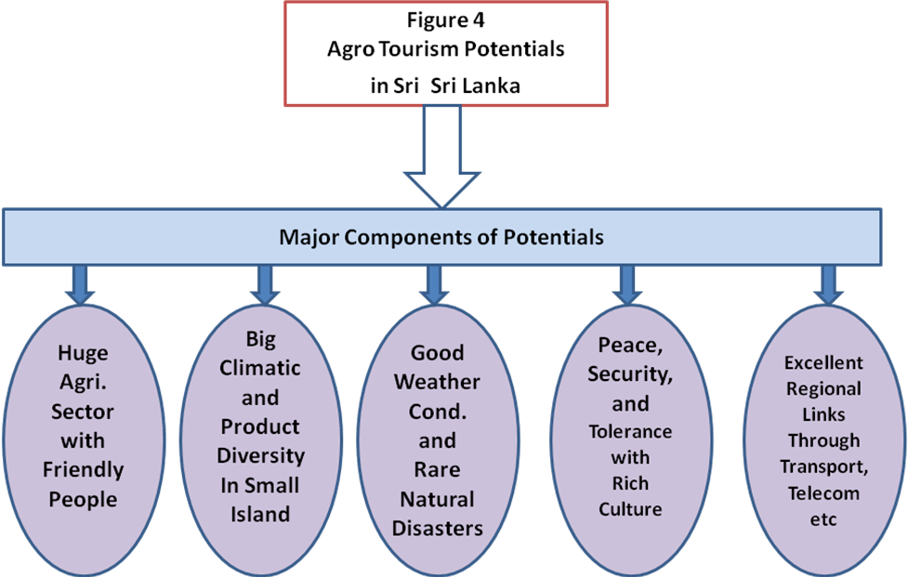

Nevertheless, farmers are simple and hospitable. Sri Lankan villages and farms can offer unique experiences including local food and accommodation. Rural areas are rich with traditional goods and services and cultural activities. Thus agro-tourism can cater to a niche market of agro-tourists.

Agro- tourism in the Nuwara Eliya District
Nuwara Eliya is a district in the Central Province, Sri Lanka. Its area is 1,228 km². Nuwara Eliya town is a tourist attraction. Nuwara Eliya is a mountain station at 1,868 m (6,128 ft) of altitude, in a splendid landscape. The city is well-kept and neat, and the always green grass gives to the locality an aspect of “colonial British style". Hence, Nuwara Eliya can be regarded as a highland tourist destination famous for its British ambience.
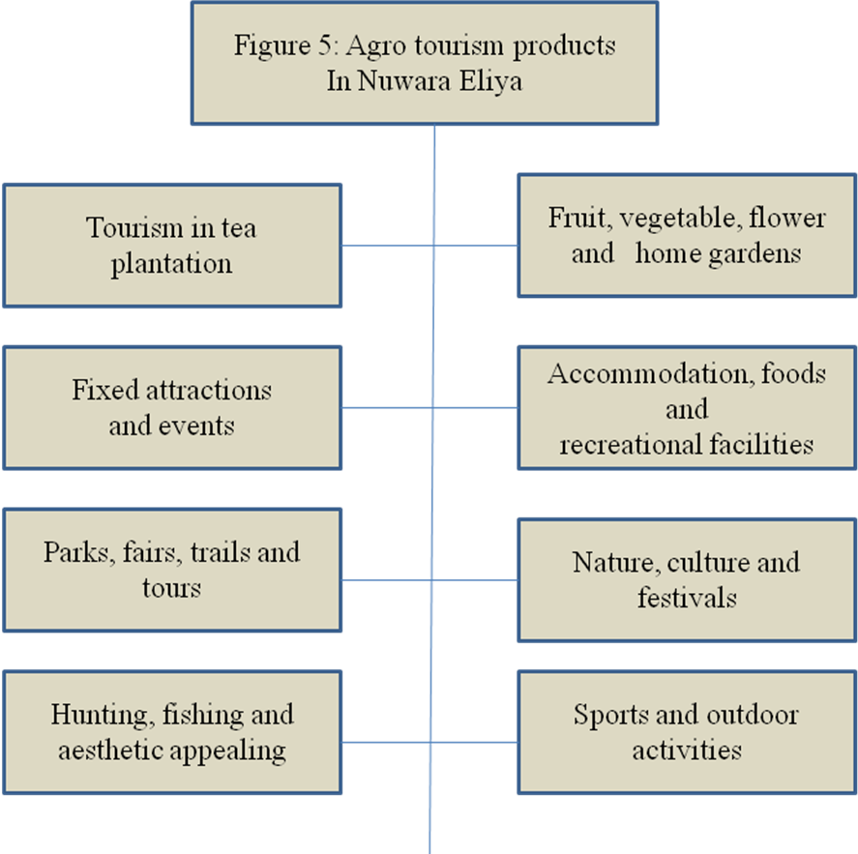
Nuwara Eliya was built entirely during the 19th century and its architecture mimics that of an English country town, with red-brick walls, country house like hill club and mock-Tudor half-timbering. Many of the buildings retain features from the colonial period such as the Queen's Cottage, General's House, Grand Hotel, Hill Club, Town Post Office and even new hotels are often built and furnished in the colonial style. Anyone who visits the city can wallow in its nostalgia of bygone days by visiting these landmark buildings. Many private homes still maintain their old English-style lawns and gardens. Nuwara Eliya's climate lent itself to becoming the prime sanctuary of the British civil servants and planters in Ceylon. Nuwara Eliya, called Little England then, was also a hill country retreat where the British colonialists could immerse in their pastimes such as fox hunting, deer hunting, elephant hunting, polo, golf and cricket.
It is also a transportation hub and an accommodation base to explore nature tourism sites in the highlands such as Horton Planes National Park, Kithulgala forest reserve and Hakgala Forest Reserve. There are many tourist attractions in and around the town. They include, Gregory Lake, Queen Victoria Park, Galways Land Bird Sanctuary, Nuwara Eliya Golf Club, Horton Plains, British tombs, Hakgala Botanical Gardens, Single tree Hill, Shanthipura, and Nissan gala Lena. Tea tourism attractions include, Oliphant Estate, Labookelle Tea Centre, The Tea Cup, The Tea Factory, and St. Claire’s Tea Centre. There are two mountains namely, Pidurutalagala and Sri Pada (Adam’s Peak) and therefore surrounding areas of Nuwara Eliya abound in opportunities for hiking and trekking.
There are a number of waterfalls within the Nuwara Eliya district and in close proximity. They include, Lover’s Leap, Glen Falls, Lakshapana, Ravana Ella, Bombure Ella, Poona Oya Ella, Ramboda Ella, Gerandi Ella, Helboda Ella, St. Clair Falls, and Ihala Devathura Ella. Nature based tourism or ecotourism is an existing tourism opportunity in Nuwara Eliya but it would be further strengthen and diversified by promoting community participation. Since it needs good guiding service, and therefore, training of local people for guiding would be important.
Although the town was founded in the 19th century by the British, the whole district is today visited by native travellers, especially during the month of April, the season of flowers, pony races, go cart races and auto rally.
The population in Nuwara Eliya, according to 2001 census is 703,610 of which 50.61 % Tamils of Indian origin, 40.2 % are Sinhalese, 6.5 % native Sri Lankan Tamils and 2.4 % Sri Lankan Moors. 51.0 % of the population are Hindu, 39.7 % Buddhists, 5 % Roman catholic, 2.7 % Muslim and 1.5 % belong to non-catholic Christian denominations. Due to the high altitude, Nuwara Eliya has a much cooler climate than the lowlands of Sri Lanka, with a mean annual temperature of 16 °C. But the temperature changes and sometimes it can be as low as 3°C. In the winter months it is quite cold at night, and there can even be frost, although it rapidly warms up as the tropical sun climbs higher during the day. The town really comes alive in April for the Sinhalese and Tamil New Year, and it is difficult to find accommodation as Sri Lankans holiday in the region during this period. The festive season starts on April 1 annually in a ceremonial manner. The ceremony consists mainly of a band show in which all the local school bands participate.
Main attractions during April season include the numerous motor racing and horse racing events. Motor racing comes alive with the Mahagastotte and Radella Hill Climbs, the former being run since 1934. The Nuwara Eliya Road Race and the 4X4 Lake Cross on edge of Lake Gregory attract a fair share of enthusiasts. Parties are held nightly in the hotels, and the season culminates in the nine furlong (1811 m) Governor's Cup, Golf Tournaments and the flower show at the end of the month.
Nuwara Eliya district has lots of potential for the introduction of agro-tourism industry which could have positive effect on the development of local people. Nuwara Eliya produces not only tea but also a variety of vegetables and fruits that are rare in other parts of Sri Lanka. Local agricultural activities have potential for agro- tourism and to contribute to the diversification of tourism products. Out of the total population, there are a significant number of farmers with farm lands and some other facilities that are important in agro-tourism development. Most of the farmers also have basic knowledge and skills required for farming. Further, different important features of these areas are able to attract visitors in a great deal. Also, the extent of agro-tourism will never overlap with other rural tourism operations.
Sri Lanka needs to attract high spenders by promoting Special Interest Tourism (SIT) such as Medical tourism and agro tourism so that people who are interested in these areas can come for these vacations.
Tea Tourism
In the area of agro tourism, there is much potential to promote the Tea Industry as one of the tourism products and a new market segment to develop Sri Lanka as a Tea-tourism destination.
The 140-year-tea history, the country's agricultural history, beautiful tea plantations and brand name of Ceylon tea, are all unique features that can be explored to develop tea tourism.
Sri Lanka has tremendous potential and opportunities to attract foreign tourists and domestic tourists through tea-tourism. It is also necessary to identify mechanisms and strategies on how tea-tourism can be incorporated into the overall tourism strategy through measures such as product development, promotions and formulation of policy decisions, development of value added products in tea-tourism and more importantly in enhancing benefits to the local community through pro-poor partnerships to alleviate poverty. It is also worthwhile to select a few tea plantation areas where tea-tourism could be developed as a pilot project.
Social life too, gets benefits from tea-tourism and the tourists can see way of life of the people in the tea plantations. Tea Tourism helps to protect our natural environment and creates natural greenery. Tea-tourism can create more income for the people, reduce or reverse migration of labour. It also can create more employment opportunities within the district. Considering the current and future tourism expectations on tea-tourism, product development, stakeholder cooperation and tourism promotion are necessary for the future development of tea-tourism.
Agricultural Cooperative Society Ltd. (AGCO) Training Centre
AGCO provides diverse agro-tourism facilities in Nuwara Eliya. At AGCO Educational/Awareness programmes are conducted for school children, university students, employees of public institutions, pilgrims and private travellers. Accommodation and meals are provided for a reasonable charge and the rates are much lower than that charged by hotels and home stay etc. in and around Nuwara Eliya. Apart from the training imparted on how crops and flowers are grown etc. the centre provides opportunities to visit places / locations where various crops and flowers are grown (e.g. Seetha Eliya for potatoes). Training programmes on floriculture and visits to various places where flowers and flower plants can be bought, are also arranged. Training programs are also conducted on ornamental fish (Trout fish are found only at Worlds End), herbs, and different types of animal and other wild life species. It also has a Pack House where participants can observe how vegetables are processed and packed. The participants can see how crops are grown and animals are reared, can taste foods prepared with fresh vegetables, consume fresh milk and fruits etc. purchase pots and plants through the programmes arranged by AGCO. This can be regarded as a well organised agro-tourism activity in Nuwara Eliya.
According to a study done by the Canadian Tourism Commission the following table presents the top ten travel motivations of key overseas agritourism travel markets namely, Japan, United Kingdom and Germany.

Table 4: Top ten travel motivations of key overseas agro tourism travel markets

Japan | United Kingdom | Germany
- Outstanding scenery  - Variety of things to see and do  - Opportunity to increase one's knowledge  - Historical or archaeological buildings and places  - Environmental quality of air, water and soil  - Just relaxing  - Destinations that provide value for my holiday money  - Nice weather  - Having fun, being entertained  - Standards of hygiene and cleanliness | - Variety of things to see and do  - Opportunity to increase one's knowledge about places, people and things  - Personal safety, even when traveling alone  - Interesting and friendly local people  - Nice weather  - Standards of hygiene and cleanliness  - Destinations that provide value for my holiday money  - Inexpensive travel within the Country  - Outstanding scenery  - Inexpensive travel to the country | - Opportunity to increase one's knowledge about places, people and things  - Variety of things to see and do  - Outstanding scenery  - Personal safety, even when traveling alone  - Interesting and friendly local people  - Destination that provides value for my holiday money  - Environmental quality of area  - Historical or archaeological buildings and places  - Nice weather  - Chances to see wildlife, birds and flowers not normally seen

Source: Canadian Tourism Commission Pleasure Travel Market Studies

The above table shows the top ten (10) travel motivations of travelers from Japan, United Kingdom and Germany visiting rural agro- tourism destinations worldwide. Although the priorities assigned do change the top ten motivations are more or less the same in all the three travel markets. these motivational considerations are needed to be taken into consideration in promoting agro-tourism in the Nuwara Eliya District as well. Thus, it becomes necessary to improve tourist infra-structure, provide signage and other tourist information, and provide training of tourism related skills that would promote rural people to tap the tourism opportunity.
Table 5 presents a few proposals to develop nature and agro- tourism in Nuwara Eliya. The proposals include those which are suitable for Nuwara Eliya district as a whole and also include eco tourism activities as well. This is because agro-tourism is part of ecotourism which tries to diversify the tourism products. They are categorized under four themes namely, Fixed Attractions, Events, Recreational Services and Other Services.

Table 5: Agro tourism development themes in Nuwara Eliya
Fixed Attractions | Events | Recreational Services | Other Services
Historic Places and Buildings  Visits to Ramayana sites( Seetha Eliya Kovil, Hanumanta Kovil at Ramboda)  Colonial Type Buildings (Queens Cottage, General’s House, Grand Hotel, Hill Club and Town Post Office)  British Tombs | Conferences  Corporate  Family Reunions  Weddings  Get-togethers | Water-based Activity  Boating/Canoeing  Swimming  Tubing and Rafting  Fishing with the hook | Accommodation  Bed & Breakfast  Camping  Youth Hostels  Elder Hostels
Parks  Hakgala Botanical Gardens  Queen Victoria Park  Horton Plains National Park  Kande Ela Educational Forest Garden | Agricultural Fairs  Food and Craft Shows  Food Cooking- Demonstrations  Flower Shows | Trail Based Activities  Hiking  Off- Road Motor Cycling  Mountain biking  Cycling  Horse Racing  Motor Racing | Tour Operations  School Tours  Picnicking  Organic Farm visits
Religious Places  Holy Trinity Church  St. Xavier Church  Bambarakele Sri Maha Vihara  Jumma Mosque  Sri Muthumariamman Kovil | Seasonal Festivals/ Activities  Sinhala & Hindu New Year Festival  Paddy Harvesting  Threshing (traditional)  Ploughing with Bullocks  Transplanting  Plucking Beans  Strawberry Harvesting  Tea Plucking (Bag on the Back)  Christmas Trees  Easter Eggs | Nature Appreciation Activities  Photography/Painting  Bird watching(Galways Land Bird Sanctuary, Horton Plains)  Wild Life Viewing  Kitulgala Forest Reserve  Hakgala Forest Reserve  Kande Ela Reserve | Retailing of Various Items  Gift/ Craft/ Antique  Floral Arrangements  Gardens/ Nurseries(Flowers, Greenery, Herbs, Dried Flowers)  Roadside Stands/ Markets  U-Pick Operations  Specialty Food and Craft Products  Tea Centers
Food Processing Facilities  Spice  Chocolate  Jam /Jelly  Herb  Livestock Operations e.g.Ambewela Milk  Tea Factories, New Zealand Farm |  | Outdoor “ Hard Adventure” Activities  Rock / Hill Climbing  (Pidurutalagala, Sri Pada)  Hiking/Trekking  Cave Exploring  Pony rides  Horse Racing  Motor Racing (Mahagastota and Radella Hill Climbs)
Recreation Facilities  Archery Range  Camping/Picnicking Areas  Nuwara Eliya Golf Club |  | Outdoor” Soft Adventure” Activities  Fossil/Rock Collecting  Farm Vehicle Rides (Bullock Cart, 2 Wheel Tractor)
Natural Areas& Water Bodies  Gregory Lake  Single Tree Hill  Shanthipura  Nissan gala Lena  Water Falls (More than Ten) |  | Hunting and Fishing  Trapping fish with nets  Hunting  Dog Training  Habitat Improvement
Working Farm Structures
Green Houses
Poly Tunnels
Ambewela Farm
New Zealand Farm
Agricultural Museums and Displays
Source: Information Gathered by the Authors from Field Work and Literature Search
Also, given below are some other tourism potentials which are prevailing at present in the Nuwara Eliya and which have the potential to develop further.
Trekking Sights  - Adam’s Peak  - Horton Plains  - Kirigalpotta Mountain  - Thotupola Mountain  - Waterfall tours | Mixed Activities  - White Water Rafting  - Mountain biking  - Horse Back adventures  - Scenic Hill Country Railway Tours  - Flora and Fauna Study Tours  - Rain Forest Exploration  - Sea Planes / Helicopter Rides
Popular Bird Watching Sights  - Galway’s Land Bird Sanctuary  - Horton Plains  - Victoria Park  - Hakgala Botanical Gardens  - Gregory’s Lake Wetlands  - Bomburuella | Identified some new tourist production  - Ragala - Trekking track of Historical Area (Garundagela" Manthri thenna" Dorawa" Pandithayakumbura" Rupaha and Kotamba)  - Walapane – Foot Track (Manilwala" Thibbotugoda" Thawalama) Very remote area  - Rathnayaka pathna – Ragala  - Kotagala View Point

Conclusions
In developing countries like Sri Lanka, tourism has become one of the major sectors of the economy, contributing to a large proportion of the National Income and generating significant employment opportunities. The tourism industry has become the fastest growing service industry in the country with great potentials for its further expansion and diversification. Agri-tourism is all about unravelling various facets of village life. This includes opening up farms to tourists from cities and abroad, and letting them spend some time in the lap of nature. Apart from telling them about the various crops and how they are sown and harvested, agri-tourism exposes tourists to authentic food, handicraft, dress, culture, music and language. Tourists get to indulge in rural activities such as bullock-cart rides, milking cows and goats and picking farm-fresh fruits and vegetable. The activities may vary from village to village.
Basically, agri-tourism should ensure the following three basic necessities.
1. Have something for visitors to see:-
Animals, birds, farms and nature are the few things which Agri-tourism could offer to the tourist to see. Apart from these, culture, dress, festivals and rural games could create enough interest among foreign tourists in Agritourism.
2. Have something for visitors to do:-
Participating in agricultural operations and swimming, bullock cart riding, pony riding, buffalo riding, cooking and participating in the rural games are the few activities in which tourist can take part and enjoy.
3. Have something for visitors to buy:-
Rural crafts, dress materials, farm gate fresh agriculture products, processed foods are the few items which tourist can buy as souvenir for remembrance.

However, in Sri Lanka Agro- tourism is at an infant stage and is poorly organized. In most of the farms, infrastructure facilities are not sufficiently available. This is one of the factors that determined the success of the industry. Therefore, provision of basic infrastructure such as road facilities, clean water, and electricity is very important. Moreover, there is low awareness of agro-tourism and its attractiveness with farmers and other stakeholders. Making them well aware of agro-tourism and creating a positive attitude towards opportunities of agro-tourism is essential in order to have agro-tourism operations. Although farmers have basic knowledge and skills in farming, they are poor in business management skills namely entrepreneurship, management skills, interpersonal and communication skills etc. Therefore, education and training in these areas are very much important for the successful agro-tourism operations.

Tourists Guides in Sri Lanka and travel operators have very little knowledge about the benefits resulting from agritourism. Training programmes to cater to the needs of these individuals need to be conducted. Further, another important aspect for the successful agro-tourism operation is to make arrangements to get necessary financial facilities for the farmers to renovate and arrange agro-tourism destinations in an attractive manner. This activity needs large amounts of money and effort. If farmers can have access to credit or loan facilities under concessionary rates, it would be an ideal solution. Some farmers also fear that letting foreigners to visit their farms is risky, because some foreigners can introduce harmful insects intentionally to their farms. Thus there is a need to conduct awareness programmes to dispel such doubts from the minds of the concerned farmers.

Finding proper remedies for the above mentioned problems is an essential prerequisite as the potential entrepreneurs will face difficulties to start a business without external support. After that, introduction of agro-tourism under the themes suggested earlier would be of great significance and would improve the overall economic, social, cultural, and aesthetic level of the areas.
In conclusion it can be said that, ‘Agriculture has been the oldest vocation in all countries since the Neolithic revolution. It is still the centre of gravity of livelihoods, culture, social values, and politics in many [developing] countries. You need a fair deal if you are to maintain the delicate socioeconomic equilibrium in your country.’ This is equally valid when agro tourism is promoted in many regions of the developing countries including Nuwara Eliya district of Sri Lanka.
References
Adam, K. L (2004) Entertainment farming and agri-tourism, Business management
Guide. National Centre for Appropriate Technology, USA.
http://attra.neat.org/attra-pub/PDF/entertn.pdf.
Advisory panel on community based sustainable tourism in Sri Lanka (2008) Report on
Community based sustainable tourism. Colombo, Sri Lanka.
Colton, J.W. and Bissix, G. (2005) Developing agritourism in Nova Scotia: Issues and
Challenges. Journal of Sustainable Agriculture. Vol.27, No.1, pp 91-112.
District Planning Office, Nuwara Eliya (2011) Nuwara Eliya District- Information on Places of Tourist Attraction (in Sinhala)
Huybers, T., (2007) (Ed) Tourism in Developing countries, Economics and management
Of tourism. Edward Elgar publishing Limited, Massachusetts, USA.
Keith, D. Rilla, E., George, H., Lobo, R, Tourte, L and Ingram, R (2003) Obstacles in the
Agritourism regulatory process: Perspectives of operators and officials in ten California countries. http:// www.aic.ucdavis.edu
Lamb R (2008) How Agritourism Works, http://adventure.howstuffworks.com/agritourism.htm/printable.
Nilsson, P. A (2002) staying on farms: An ideological background. Annals of Tourism Research, Vol. 29, No.1, pp7-24.
Sharply, R (2002) rural tourism and the challenge of tourism diversification: the case of Cyprus. Tourism Management, Vol. 23, No. 3, pp233-244
Singh, R. (2007) Agritourism in India, http://www.managementparadise.com/forums/archive/index.php/t-19506.html.
Sri Lanka Tourism Development Authority, http://www.sltda.gov.lk
Taware, P (2009) Agri – tourism: innovative supplementary income generating activity for enterprising farmers www.scribd.com/.../Agri-Tourism-India-Concept-Note-By-Pandurang-Taware-Director-Agri-Tourism-Development-Corporation
Veeck, G., Che, D. and Veeck, A (2006) America’s changing farmscape: A study of agricultural tourism in Michigan. Professional Geographer, Vol.58, No. 3,
Wall, G (2006) The nature of urban and community tourism. W. Jamieson (Eds.), Community Destination Management in Developing Economics. The Haworth Hospitality Press, New York.
Weaver, D.B. and Fennell, D.A (1997) The vacation farm sector in Saskatchewan: a profile of operators. Tourism Management, Vol.18, No.6, pp357-365.
Wicks, E. And Merrett, C. D (2003) Agritourism: An economic opportunity for Illinois.
http://www.iira.org/pubsnew/publication/IIRA- RRR-577.pdf

Wimalaratana, W (2011) Agricultural Information for Food Production in Sri Lanka, in Wijitapure Wimalaratana (Ed.) Agriculture and Rural Development in Sri Lanka: S.M.P. Senanayake Felicitation volume, Department of Economics, University of Colombo.

Wimalaratana, W and Silva, D A C (2009) Community Based Sustainable Tourism: A Case Study of the Monaragala District, Sri Lanka Jouranal of Agraian Studies, Vol.13, No1, 2009.
Wimalaratana, W and Silva, D A C (2009) Tourism Resources in the Western Province of Sri Lanka-I, Colombo.

Wimalaratana, W and Silva, D A C (2009) Tourism Resources in the Western Province of Sri Lanka-II, Colombo.

Wimalaratana, W and Silva, D A C (2006) Community Based Sustainable Development Tourism with Special Reference to Monaragala District, in Lanka, Olanda Publishers, Arawwala, Sri Lanka.
Wimalaratana, W . Wayamba Palaath Pas Avurudhu Sangvardhana Selesma (2005) , UoC Community Development Center, Colombo, [Contributor to Tourism and Industry sectors]

Former Dean, Faculty of Arts and Former Head Department of Economics, University of Colombo, Sri Lanka, smpsena@gmail.com
Senior Lecturer and Director of Development Resource Center, Department of Economics, University of Colombo, Sri Lanka, wwimalar@yahoo.co.uk
Wijitapure Wimalaratana, BBC, Dismay at the Collapse of Trade talks (Comments), 30 July 2008.

